candidate’s Data SHEET
DATE OF FILLING:

First Name | Mayur | Middle Name | Murlidhar
Last Name | Dhopte | Nationality | Indian
DOB | 24/03/1999 | Sex | Male
Marital Status | Unmarried
Total Years of experience | 3.2 Years
Expected Date of Joining | 08/07/2024
Present Company | Pentachrome Technologies Pvt. Ltd. | Fixed salary  Variable salary  Total salary | 4.6 LPA
Present Company | Pentachrome Technologies Pvt. Ltd. | Fixed salary  Variable salary  Total salary | -
Present Company | Pentachrome Technologies Pvt. Ltd. | Fixed salary  Variable salary  Total salary | 4.6 LPA
Highest Qualification & Stream | BE (Mechanical) | Year of graduation | 2020
Passport No. | X3980191 | Expiry Date | 21/02/2034
Visa Status [with expiry date]
Pan Card No. | HCSPD8450A
Aadhar No. | 573092044659
Email ID: | mayurd24it@gmail.com
Phone #: | 8983895544
Current Address: | #36  Kalyani PG for gents, 2nd cross,4th main, Abayappa Layout, BTM 2nd Stage, Bengaluru, Karnataka 550076
Permanent Address: | #539 Telipura, Sitabuldi, Nagpur, Maharashtra 440012

Education details (Starting from SSLC to the highest educational degree)
Education | Institute | Specialisation | Passing Year | % of Mark
10th/SSC | Hadas High School, Nagpur | - | 2014 | 78.60
12th/HSC | Nabira Mahavidyalaya Katol | Science | 2016 | 54
BE(Mechanical) | SB Jain Institute of Technology | Mechanical | 2020 | 7.67 CGPA

Professional Certifications (Details of any additional certification courses completed)
Course Description | Institute | Passing Year | % of Mark
Java Development Certification | JSpiders, Bengaluru

Previous Company and Designation (Descending Order) Please add additional rows if required
Company Name | Start Date | End Date | Designation | Reporting manager- Name & Ph. No. | HR-Name & Ph. No.
Pentachrome Technologies Pvt. Ltd. | 19 April 2021 | 30 June 2024 | Software Engineer | Shekar M  080-50956285 | Ms. Archana S  080-50956285

What other companies have you applied to recently?
NetConnect Global, Telaverge , Photon
Do you have any constraint in relocation/travelling to other locations for project needs?

- No
Do you have any planned leaves/holidays in the next 3-6 months?

- No

Additional Details
Strengths
- HardWorking, Good Team Player, problem solving skills
Weaknesses
Try to be Perfect, but sometime it a lot of time that’s not good in some situations
What are your criteria to join a company?
Expecting good work life balance, willing to provide me opportunity to grow and learn
What knowledge areas and technical skills are your strongest?
Core java, Spring Boot, Hibernate, Microservices, MySQL, REST API, Kafka, Postman
Any additional skills or experiences that you did not include in your resume that we should know about?
-

What are the key motivators that encourage you to perform at your best?
A better Future, Stable and good career growth
Where do you expect to be in the next two years?
Would like to see growing and learning in life and at better position in an organization

Languages Known (Tick mark your language proficiency level below)
Language | Read | Write | Speak
Marathi | y | y | y
Hindi | y | y | y
English | y | y | y

Personal Details
Father’s details | Name: Murlidhar V. Dhopte  DOB: 05/06/1965  Occupation: Business
Mother’s details | Name: Sangita M. Dhopte  DOB:08/09/1975  Occupation: HouseMaker
Spouse’s details | Name:  DOB:  Occupation:
Kid’s details | Name:  DOB:
Siblings details | Names: Sakshi M Dhopte
If medical insurance coverage required for parents, mention YES/NO | Yes
Hobbies | Gaming, World Affairs, Listening to music
Blood Group | -
Emergency contact person’s details | Name: Sakshi Dhopte  Contact number: 9657354962  Relationship: Sister

Authorization / Declaration and Undertaking
I Certify that the statements made in this application are valid and complete to the best of my knowledge. I understand that false or misleading information may result in termination of employment
If upon investigation, any of this information is found to be incomplete or inaccurate, I understand that I will be subject to dismissal at any time during my employment.
I hereby authorize and / or any of its subsidiaries or affiliates, and any persons or organization acting on its behalf to verify the information presented on this application form and to procure an investigation report or consumer report for that purpose.
I hereby grant authority for the bearer to access or to be provided with full details of my previous record. In addition, please provide any other pertinent information requested by the individual presenting this authority
I hereby release from liability all persons or entities requesting or supplying such information
I authorize to contact my present employer | yes | y | No
I authorize to contact my past employer | yes | y | No
I have read, understand, and by my signature consent to these statements

Signature | 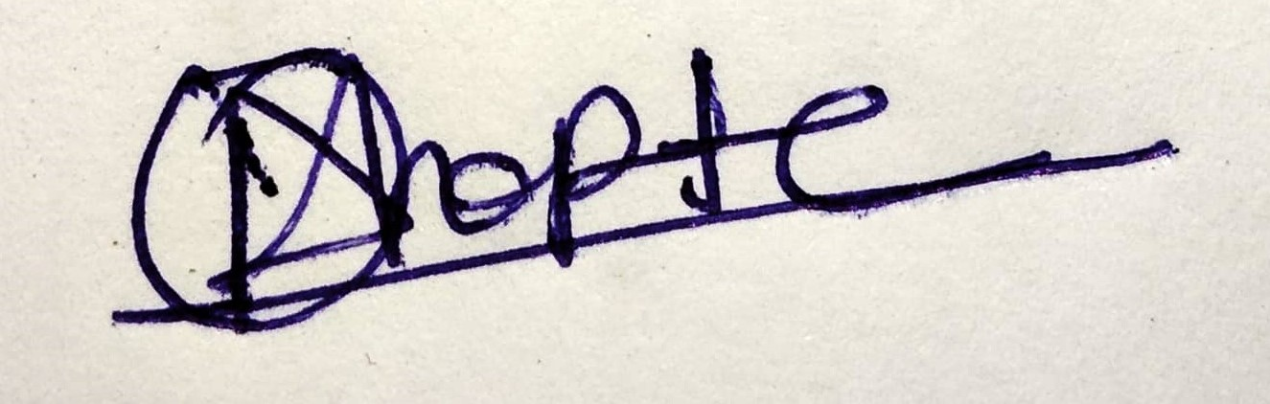
Name | Mayur Dhopte
Date | 02/07/2024

